

**THE RUSSELL FIELD COURSEWORK**

**BY**

**NAME: JUSTINE IHIONU OBINNA**

**STUDENT NUMBER: B1132111**

**MSC OIL AND GAS MANAGEMENT**

**SCHOOL OF COMPUTING, ENGINEERING AND DIGITAL TECHNOLOGY**

**OIL AND GAS ECONOMICS AND CONTRACTS**

**CBE 4031**

**ACADEMIC YEAR: 2021/2022**

**DATE: 3RD DECEMBER 2021**

**EXECUTIVE SUMMARY**

This study appraises the cash flow and net present value of Russell Oil Field for Petro-Canada, which purchased a 30% equity in the field in the year 2004. This was done as Petro-Canada’s risk mitigation of the field, a very important activity to carry out in order to estimate the company’s return on Equity and potential profits or losses. A cash flow model was thus created using Microsoft excel and Palisade’s @RISK, spanning the years from 2001 up to abandon in 2017. Final values generated revealed a Net Present value of $2,779,330,131. Sensitivity analyses were also carried out, revealing a high influence of inflation rates on the NPV output but a low influence of discount rates. Similarly, changes in tax rates were shown to have a high effect on the NPV, as well as oil prices. However, uncertainties in gas prices shown much less effects compared to both. Finally, the work concludes that the Russell Oil field is one with high potential for profits and low risk levels, and that Petro-Canada’s estimated profits represent more than a 15% Real rate of return on the field.

**TABLE OF CONTENTS**

Executive Summary ………………………………………………………………………….. 2

Table of Content ……………………………………………………………………………… 3

List of Figures ………………………………………………………………………………… 4

Risk Management and Risk Mitigation in Oil and Gas Field …………………………….. 5

Russell Field Cash Flow Model ………………………………………………………………7

Sensitivity Analysis …………………………………………………………………………… 8

Findings and Discussion …………………………………………………………………….. 10

References ……………………………………………………………………………………. 12

**LIST OF FIGURES**

Fig 1: Cash Flow Graph …………………………………………………………………….. 8

Fig 2: Tornado Graph for Inflation and Discount rates …………………………………... 9

Fig 3: Tornado Graph for Tax, oil and gas prices ………………………………………… 9

Fig 4: Discounted Cash Flow Distributed Graph ………………………………………… 10

**RISK MANAGEMENT AND RISK MITIGATION IN OIL AND GAS FIELD**

A risk is an uncertain event or condition that may have a positive or negative effect on at least one of the project objectives (Riaz, 2017). Risk mitigation can be simply defined as strategies utilized in preparing for and lessening the effect of risks, uncertainties, and threats faced by a business. Kenton on Investopedia puts it as the process of identification, analysis, and acceptance or mitigation of uncertainty in investment decisions (Kenton, 2021). Risk mitigation is one step in risk management process, starting from the identification of the risk, analysis of the impact of the risk, tracking the risk, mitigating and monitoring the risk, and performing a risk prioritization analysis. Any financial or economic action taken by a company or business organization is fraught with danger. As a result, in modern times, the risk identification, assessment and management process has been integrated into the strategic development of businesses.

There are many high-cost risks involved in Petroleum field, ranging from environmental to economic risks, and present in all phases of its production lifetime, from exploration to distribution. Risk defining factors are quite diversified, including political, geological, technological, and economic uncertainties. In other words, as Oil and Gas companies are always influenced by oil prices in the global market, natural phenomena such as Tsunamis and Earthquakes, and imposed governmental sanctions in regards to equipment and technologies, they must make a lot of adjustments to their business strategies.

There are three main types of risk unique to the oil and gas industry. The first is the prospect risk. This is a risk of the oil well failing to produce commercial quantities of crude oil, natural gas, and other hydrocarbons. In other words, the well could run dry before profits could be made. Investors, of course, are very concerned about prospect risk because of the high costs of drilling. However, as time progresses and technology increases, the likelihood of the dry-hole scenario diminishes further. The second type of risk is the contract risk. In this, a company fails to generate enough revenue to still result in profits after paying off sharing agreements signed into contract with governments. The third type of risk is the commercial risk. This risk has to do with the market and economic factors, as well as geological factors. The market conditions must be taken into consideration (for example, volatility in oil prices throughout the year). In another scenario, the geology of the field could be significantly more fragmented, or the size of the oil deposit substantially smaller than surveys and geological and geophysical studies sugessted (Mu, 2013).

In fact, the risks inherent in the oil and gas industry are so inevitable that steps are decision analysis methods are undertaken, not to reduce the risk, but to evaluate, understand and quantify it (Hayashi *et al*, 2010). Thus, there is a great need for effective risk management systems, especially when taking into account the high cost of any errors inherent, the complex structures of oil and gas organizations, and the necessity of making quick managerial decisions. (Lenkova, 2018)

Successful decisions require the combination of at least one good risk analysis method with the input of an expert in decision-making processes, and of course, one’s own personal judgement (Hayashi et al, 2010). In circumstances of uncertainty, the decisional process is based on rationality, along with quantitative calculations. It is important to note here that risk assessment may be either qualitative or quantitative. Qualitative assessments are subjective and prioritzed based on probability and impact, while quantitative techniques are objective and numerical based. Because there are factors that can never be known for certain, risk analysis in the oil and gas field requires the use of quantitative probabilistic techniques such as sensitivity analyses, monte-carlo simulations, and FMEA. These tools, through the use of mathematical formulas, enable the user to see how various situations will affect an eventual outcome. Sensitivity analysis, for example, determines how different values of one or two input variables affect a particular dependent variable under a given set of assumptions.

Another important use of risk analysis techniques is in figuring out how profitable an investment will be. In the oil and gas industry where large amounts of capital are expended in the opening phases of exploration, this is critical. Risk analysis methods, therefore, show a potential investor his expected return on equity even before the field kicks off exploration and production. The investor or fund-manager investigates and accesses the risk of the venture before taking the appropriate action based on their risk tolerance and investment objectives (Hallikas *et al*, 2004)

There are various types of risk mitigation strategies. These strategies could be and are often used in combination with each other. However, strategies chosen in preference over each other are picked depending on the company’s risk landscape (Lutkevich, 2021). These strategies include risk avoidance, risk acceptance, risk transfer, and risk monitoring. Risk avoidance involves staying away from activities which inform the risk, usually undertaken if the costs are deemed too high. This is a very common business strategy in companies around the world. As aforementioned however, Oil and gas companies cannot do this as the risks inherent in the industry cannot be avoided. Risk acceptance, on the other hand, is the exact opposite of risk avoidance. In this case, the cost of servicing the risk is greater than that if it does occur, usually because of the presence of other more pertinent risks. Thus, the risk is accepted for a given period of time in order to prioritize mitigation efforts on those other risks. Risk transfer can also be described as risk sharing. Here, risk is allocated among different parties based on their ability to mitigate or protect against the risk. Finally, risk monitoring, which in itself is a part of the risk analysis process, is the act of watching projects and the associated risks for changes in the impact of the associated risks.

**RUSSELL FIELD CASH FLOW MODEL**

A cash flow model was created in MS Excel to compute the values of oil and gas to be produced from the Russell Field from its inception in to abandon in using a discounted cash flow model. An assumed discount rate of 15% was utilized. The model builds from the year 2001 to 2017. However, the year 2004 was considered as year zero for the net present value and cash flow analyses. Net Present Value of the field was estimated to be $2,779,330,131.

Figure 1: Cash Flow Graph

**SENSITIVITY ANALYSIS**

Sensitivity analysis was carried out based on the inflation rate and assumed discount rate. Afterward, a risk simulation was run using palisade’s @RISK add-in to MS Excel and the correlation coefficient Tornado chart generated, showing the relationship between inflation and discount rates to the final NPV calculated.

An additional sensitivity analysis was then carried out, comparing the influences of corporate tax rates, oil prices and gas prices to the final NPV calculated. The tornado chart was also generated.

Figure 2: Tornado Graph for Inflation and Discount rates

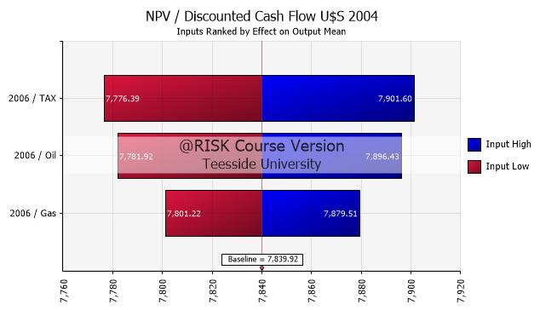

Figure 3: Tornado Graph for Tax, oil and gas prices

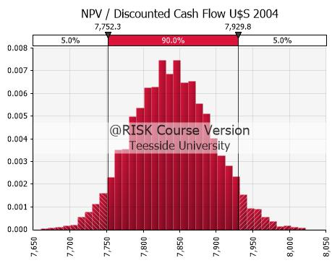

Figure 4: Discounted Cash Flow Distributed Graph

**FINDINGS AND DISCUSSION**

The Russell Oil field was stated to begin production in 2006, therefore cash flow analyses began from that year. However the year 2004 was chosen as year zero to begin NPV analysis as this was the year Petro-Canada bought its 30% equity. An assumed discount rate of 15% was used in the analyses as this best represents real life average discount values in oil and gas.

After carrying out a careful appraisal of the Russell oil field in 2004, the model clearly shows that the price Petro-Canada paid for its 30% equity represents more than a 15% real rate of return. A view at the cash-flow graph reveals that cash flow is most likely to peak in 2007 (second year of production) and decline steadily afterwards. The graph also justifies the abandon of the field in 2017 and cash flow is shown to have reached very low levels.

The sensitivity analysis carried out revealed a high influence of inflation rates to the cash flow, but a very low influence of discount rates. Therefore, while inflation rates are expected to be a steady 3%, any changes will result in a great difference in the final NPV calculated. The sensitivity analysis on tax, oil and gas prices showed a greater correlation of tax rates to the cash flow and NPV, followed by oil prices with a slightly lesser correlation and gas prices at the bottom of the chart. This is unsurprising as gas not only has lesser prices than oil but is produced in lesser quantities in the plant.

Finally, the Russell Oil Field is, by all calculations, a highly profitable field with low risks levels and few uncertainties.

**REFERENCES**

Borghean, F & Boghean, C. (2017). ‘Risk Management in the Decisional Process in Llamas, B. *Key Issues for Management of Innovative Projects.* Pp.101-119.

Hallikas, J., Karvonen, I., Pulkinnen, U., Virolainen, V. & Tuominen, M (2004). ‘Risk manaement Processes in Supplier Networks’. International Journal of Production Economics, 90(1), pp.47-58.

Hayashi, S.H., Ligero, E.L., Schiozer, D.J. (2010). ‘Risk Mitigation in Petroleum Field Development by Modular Implantation’. *Journal of Petroleum Science and Engineering*, 75, pp.105-113.

Katende, N., Kibe, A., Kubwimana, D. (2017). ‘Implementing Risk Mitigation, Monitoring, and Management in IT Projects’. The Computer Journal,

Kenton, W. (2021). Risk Management in Finance. Available at: <https://www.investopedia.com/terms/r/riskmanagement.asp> (Accessed on 25th November, 2021)

Lenkova, O.V (2018). ‘Risk Management of Oil and Gas Company In Terms Of Strategic Transformations’. *Revista Espacious*, 39(6), pp.30-42.

Lutkevich, B. (2021). What is Risk Mitigation? Available at: <https://searchdisasterrecovery.techtarget.com/definition/risk-mitigation> (Accessed on: 28th November, 2021)

Mu, X. (2013). *Petroleum Policy and Economics.*

Ong, M. (2006). Risk management. Burlington, MA: Academic Press/Elsevier.

Riaz, A. (2017). ‘Risk Mitigation Strategies in Innovative Projects’ in Llamas, B. *Key Issues for Management of Innovative Projects.* Pp.83-100.

Risk Management and Mitigation. Available at: <https://industrialaudit.com/risk-mitigation/> (Accessed on 29th November, 2021)